O: 2018-12

AN ORDINANCE OF THE TOWN OF PHILLIPSBURG, COUNTY OF WARREN, STATE OF NEW JERSEY ADOPTING SALARY GUIDE FOR THE UNCLASSIFIED EMPLOYEES

BE IT ORDAINED by the Town Council of the Town of Phillipsburg, County of Warren, State of New Jersey the following salary guide attached hereto as Exhibit “A” is hereby adopted in order to establish a salary range and salaries for unclassified employees of the Town of Phillipsburg.

Section Two.

Severability. The various parts, sections and clauses of this Ordinance are hereby declared to be severable. If any part, sentence, paragraph, section or clause is adjudged unconstitutional or invalid by a court of competent jurisdiction, the remainder off this Ordinance shall not be affected thereby.

Section Three.

Repealer. Any ordinances or parts thereof in conflict with the provisions of this Ordinance are hereby repealed as to their inconsistencies only.

Section Four.

Effective Date. This Ordinance shall take effect upon final passage and publication as provided by law.

ATTEST: TOWN OF PHILLIPSBURG

_________________________ ___________________________
VICTORIA L. KLEINER, RMC STEPHEN R. ELLIS
Municipal Clerk Mayor
DATED: July 04, 2018
CERTIFICATION

I, Victoria L. Kleiner, Municipal Clerk for the Town of Phillipsburg, do hereby certify that the foregoing is a true copy of an Ordinance duly adopted by the Town Council at their June 19, 2018 meeting.
__________________________
VICTORIA L. KLEINER, RMC

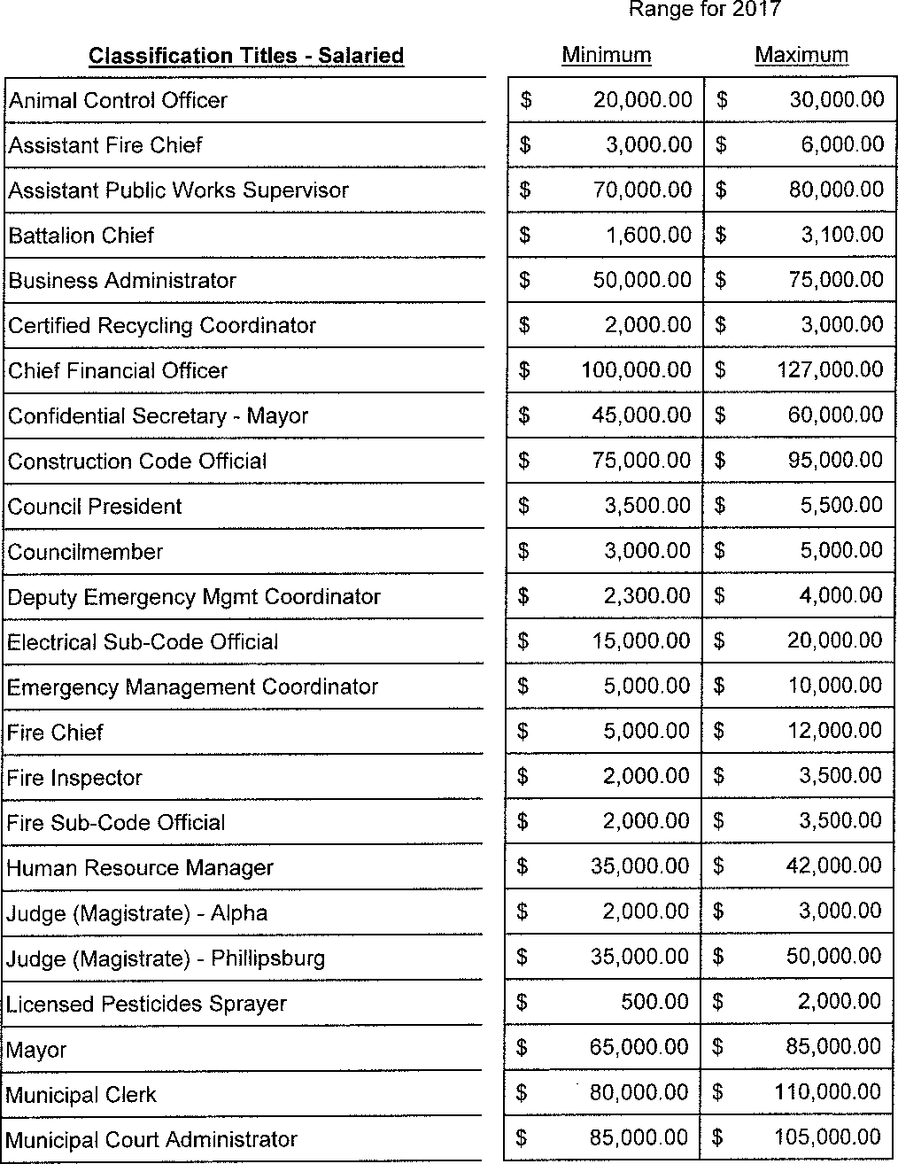
Classification Titles - Salaried
Minimum
Maximum
Range for 2018
$ 20,000.00 | $ 40,000.00
$ 3,000.00 | $ 6,000.00
$ 70,000.00 | $ 80,000.00
$ 1,600.00 | $ 3,100.00
$ 50,000.00 | $ 75,000.00
$ 2,000.00 | $ 3,000.00
$ 100,000.00 | $ 127,000.00
$ | $
$ 75,000.00 | $ 95,000.00
$ 3,500.00 | $ 5,500.00
$ 3,000.00 | $ 5,000.00
$ 2,300.00 | $ 4,000.00
$ 15,000.00 | $ 20,000.00
$ 5,000.00 | $ 10,000.00
$ 5,000.00 | $ 12,000.00
$ 2,000.00 | $ 3,500.00
$ 2,000.00 | $ 3,500.00
$ | $
$ 2,000.00 | $ 3,000.00
$ 35,000.00 | $ 50,000.00
$ 500.00 | $ 2,000.00
$ 32,500.00 | $ 65,000.00
$ 80,000.00 | $ 110,000.00
$ 85,000.00 | $ 105,000.00

Animal Control Officer
Assistant Fire Chief
Assistant Public Works Supervisor
Battalion Chief
Business Administrator
Certified Recycling Coordinator
Chief Financial Officer

Construction Code Official
Council President
Councilmember
Deputy Emergency Mgmt Coordinator
Electrical Sub-Code Official
Emergency Management Coordinator
Fire Chief
Fire Inspector
Fire Sub-Code Official

Judge (Magistrate) - Alpha
Judge (Magistrate) - Phillipsburg
Licensed Pesticides Sprayer
Mayor
Municipal Clerk
Municipal Court Administrator

Plumbing Inspector
Prosecutor
Public Defender
PW Superintendent
Public Works Supervisor
Recreation Director
Tax Assessor
Tax Collector
$ 13,000.00 | $ 25,000.00
$ 35,000.00 | $ 45,000.00
$ 8,000.00 | $ 13,000.00
$ 80,000.00 | $ 100,000.00
$ 80,000.00 | $ 100,000.00
$ 50,000.00 | $ 75,000.00
$ 76,000.00 | $ 96,000.00
$ 70,000.00 | $ 95,000.00

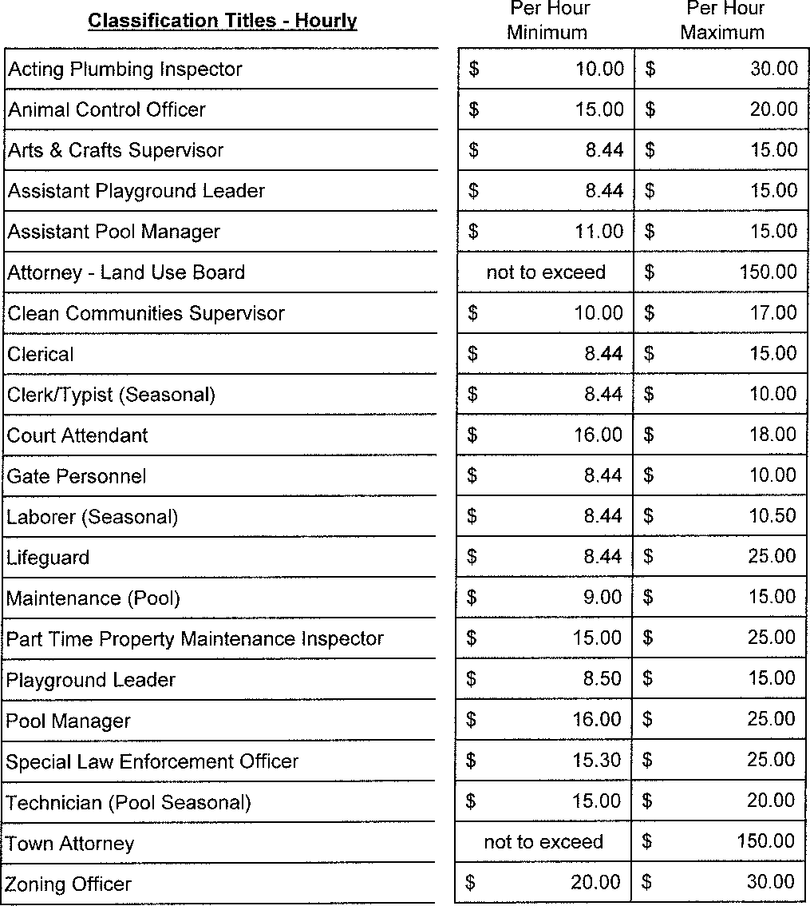
Per Hour Minimum
Per Hour Maximum
Classification Titles - Hourly
$ |  | 10.00 | $ | 30.00
$ |  | 15.00 | $ | 20.00
$ |  | 8.44 | $ | 15.00
$ |  | 8.44 | $ | 15.00
$ |  | 11.00 | $ | 15.00
 | not to exceed |  | $ 150.00
$ |  | 10.00 | $ | 17.00
$ |  | 8.44 | $ | 15.00
$ |  | 8.44 | $ | 10.00
$ |  | 16.00 | $ | 18.00
$ |  | 8.44 | $ | 10.00
$ |  | 8.44 | $ | 10.50
$ |  | 8.44 | $ | 25.00
$ |  | 9.00 | $ | 15.00
$ |  | 15.00 | $ | 25.00
$ |  | 8.50 | $ | 15.00
$ |  | 16.00 | $ | 25.00
$ |  | 15.30 | $ | 25.00
$ |  | 15.00 | $ | 20.00
 | not to exceed |  | $ 150.00
$ |  | 20.00 | $ 30.00

Acting Plumbing Inspector
Animal Control Officer
Arts & Crafts Supervisor
Assistant Playground Leader
Assistant Pool Manager
Attorney - Land Use Board
Clean Communities Supervisor
Clerical
Clerk/Typist (Seasonal)
Court Attendant
Gate Personnel
Laborer (Seasonal)
Lifeguard
Maintenance (Pool)
Part Time Property Maintenance Inspector
Playground Leader
Pool Manager
Special Law Enforcement Officer
Technician (Pool Seasonal)
Town Attorney
Zoning Officer

Per Call

Municipal Court Administrator
50.00 Per Call

Crossing Guards (New)
School Traffic Guards with sick & vacation
School Traffic Guards no sick & vacation
School Traffic Guards - additional crossing
School Traffic Guards Hourly
School Traffic Guard Coordinator
School Traffic Guard Trainee
Per Day
 | $ | 29.00
 | $ | 34.00
 | $ | 15.00
8.44 Per Hour |  | 9.25 Per Hour
 | $ | 11.00
 | $ | 10.00

